Grade 7 Accelerated · Unit 3 · Lesson 5  Applying Exponent Laws  Question Bank 3.05 ANSWER KEY | Name  Date  Period

Show your work. Circle your final answer.
For questions 1 through 4, rewrite each expression as an equivalent expression with a positive exponent.
1. 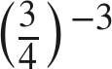
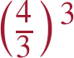

2. 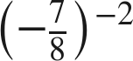
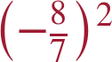
The sign stays with the fraction.

3. 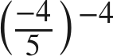
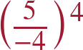

4. 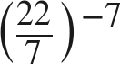
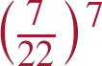

Matching.
5. Match each expression on the left with the equivalent expression on the right by writing the letter.
a. 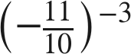 A. 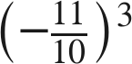 B. 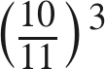 C. 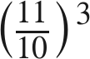 D. 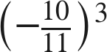
D
b. 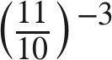
B
c. 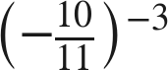
A
d. 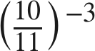
C

For questions 6 through 9, generate an equivalent expression with one base and one positive exponent. Show the laws you use.
6. 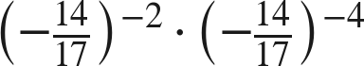
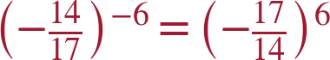
Product of powers, then flip.

7. 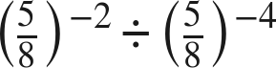
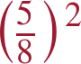
−2 − (−4) = 2; already positive.

8. 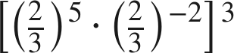
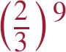
(5 − 2) · 3.

9. 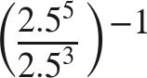
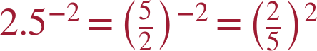
Rewrite the decimal as a fraction before flipping.

Equivalent or not.
10. Consider the expression 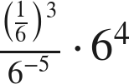. For each expression below, decide whether it is equivalent, and justify with a law of exponents.
a. 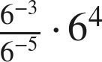
Yes — 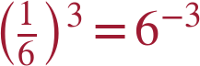, so this is the same expression; value .
b. 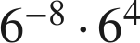
No — the quotient gives , not ; this is .
c. 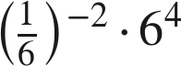
Yes — 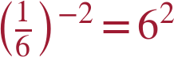, and .
d. 
Yes — it is the value of the expression written as one power.

11. Which is the value of 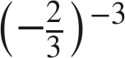 ?
● A. 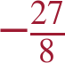
○ B. 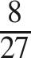
○ C. 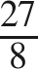
○ D. 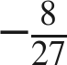
A
(−3/2)³ = −27/8.

12. Find the value of that makes each statement true.
a. 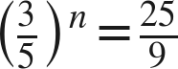
n = −2
(5/3)² = 25/9.
b. 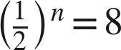
n = −3

